

Sami Says Manual
Authored by: Corey Davis, Patrick Reynolds,
Adam Roberts, and Edward Rowe

Sami Says Manual
Table of Contents
I. About Sami Says
II. Installation
- Instructions on how to install and manage the program
III. Getting Started
- A quick guide to creating a story
IV: Student Profile Management (The Bookshelf)
A. What is the student manager?
B. Adding a new student
C. Removing an old student
V. Story Management (The Storybook)
A. What is the story manager?
B. Creating a new story
C. Loading / Modifying an existing story
D. Rename a story
E. Publish a story
F. Delete a Story
G. Keyboard Navigation
H. Keybindings
VI. Story Creation
A. Parts of a story
B. Creating a title
C. Recording sound clips
D. Navigating through a story
E. Inserting sound effects
F. Modifying sound clips
G. Deleting a clip
H. Playing the story back
I. Help!
J. Keybindings
VII. Sound Library Management (Sound Prioritization)
A. What is the Sound Library?
B. Prioritizing sounds
C. Setting sound restrictions
D. Adding new sounds
VIII. Teacher Template
A. What is a teacher template?
B. Creating a template
C. Assigning a template
D. Deleting a template
E. Keybindings
VIX. Advanced Techniques
A. Sound library structure
B. Copy/Cut/Paste a sound clip
X. About the team
I. About Sami Says

Sami Says is an application designed to aid visually impaired children tell stories through sound. As an alternative to writing by hand, students are able to use Sami Says to record themselves speaking their stories aloud. The students can also choose from libraries of sound effects to insert into their story, so that they may better describe the characters and events.
In addition to being a fun writing tool, teachers can use Sami Says as a teaching aid. Features such as teacher templates and sound prioritizing allow teachers to create unique assignments for their students. Teacher templates are great for fill-in-the-blank stories, choose-your-own endings, or reading response questionnaires. Sound prioritization helps students find the sound effects that are of interest to them and the material they are studying.
Sami Says exposes children to new technology and enables them to develop their creative writing abilities by creating something that would be difficult without this assistive technology. And they'll have fun, too!

II. Installation

Step 1. Open the installer
To play Sami Says you must first install the game. Find the icon called “SamiSays Setup.exe” on your computer, and double click it.
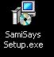

Step 2. Choose a path
After opening the installer, you will be asked to confirm you would like to install Sami Says. Press next to get to a screen where are asked where you would like to install the game. To select the default location press next, or enter a different path if you’d like.
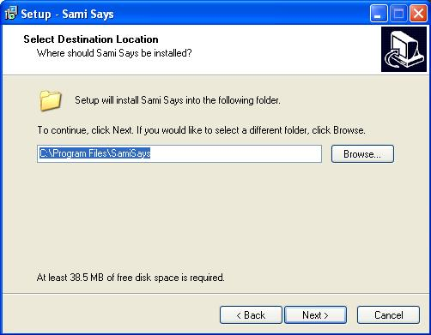

Step 3. Name the shortcut
After choosing a path, you will be asked for a name for the shortcut. It is advised to leave this as “Sami Says” though you can change it if you like. Press next to leave it as Sami Says.

Step 4. Install a shortcut
Next you will see a checkbox indicating whether or not you would like a shortcut to Sami Says on the desktop. It is highly that you leave this checkbox checked and move on to the next page by pressing the Next button.

Step 5. Verify install
Lastly, press the Install button to begin installation. There should then appear a load bar and after the load bar is filled you should see a confirmation of the program’s successful installation. Click Finish to close the installer and open up Sami Says.

III. Getting Started

Launch Sami Says by double clicking the Sami Says icon on the desktop. When Sami Says starts, you will see a title screen, as shown below, with three main buttons: The Bookshelf, Teacher Templates, and Prioritize Sounds.

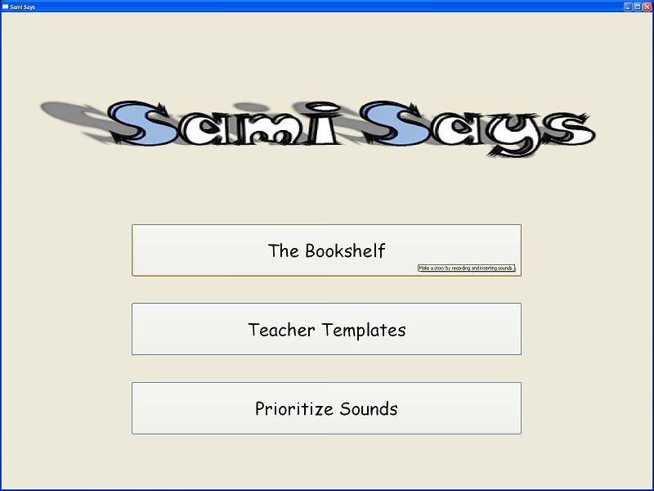

These are the three main features of Sami Says. The Bookshelf button will take you through the steps required to start creating stories, and the Teacher Templates button will take you to a variation on story creation that is designed to allow teachers to create assignments for students. Prioritize Sounds allows teachers to select any number of sounds from the sound library to be made more accessible to students and to restrict students to the use of only those sounds.

Let’s start by taking a closer look at the Bookshelf feature. After clicking this button, you’ll notice that you are taken to a screen with a blank list labeled "students" and four buttons on the right, pictured below:

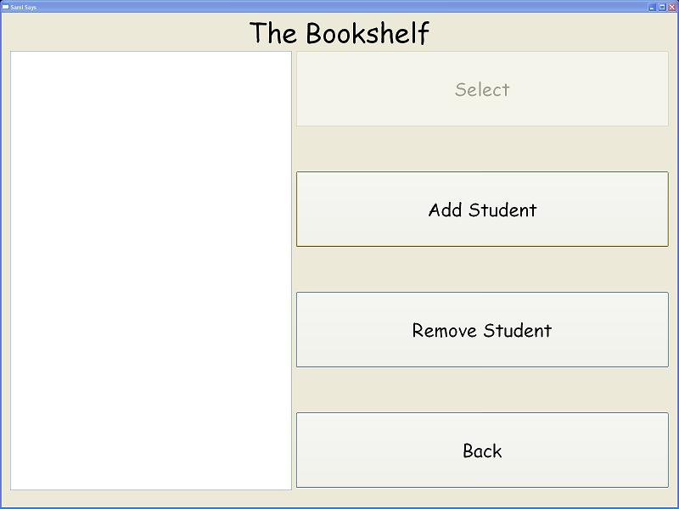

Sami Says maintains a record of your students allowing stories created by that student to only be accessible to him or her. A student’s profile is sort of like her or his personal portfolio. From the Bookshelf you can manage your student profiles, and each year you can remove last year’s students and add new ones. To get started creating a story, you will first need to create a portfolio so that Sami Says knows what name to save the stories under. Simply press the Add Student button, and type the student's name when prompted and click OK. Then, click on the student's name in the list on the left, and press the select button. You will then be directed to the student’s Storybook.
The Storybook menu is where all the selected student's stories are saved. From this menu, you are able to create new stories, rename saved stories, load and edit saved stories, publish saved stories, or delete unwanted stories. This screen is pictured below.
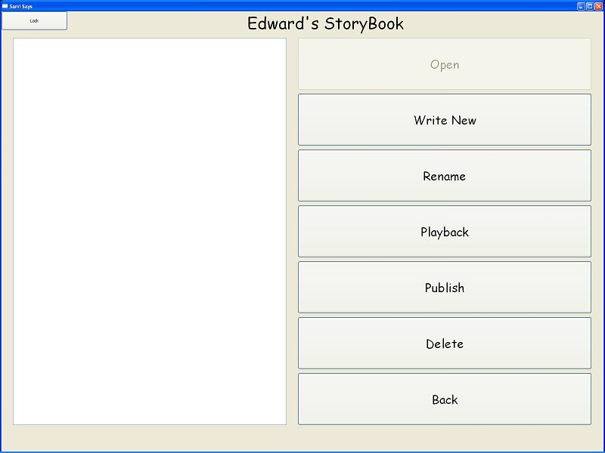

Since you will have no stories when you first launch the program, let's start by creating a new story. Click on the "Write New" button to launch story creation. After doing this you should hear a jingle and then be taken to the story creation screen where there will be a blank story that you can begin to fill in.
When creating a story you must rely primarily on your auditory senses to navigate your way around. The first (and only) thing you can do is record a title, but you can always come back and change the title if you are unsure what to name your story at this point. You can record the title by pressing and holding the space bar while you speak the title, and release the space bar to stop recording. You should see the record light turn red to indicate that you are recording while the space bar is held and go back to grey when you release the space bar. The title should then be played back for you. Once you have recorded the tile you can record the clips of your story by pressing and holding the space bar as you did with the title. After this, you can do one of five actions: record more sound clips, insert sound effects, navigate through recorded clips and effects, delete clips and sound effects, or playback the entire story. This is explained in greater detail in Section VI: Story Creation.
Stories are saved after every action you make, so you don't have to worry about losing your work. Once you are happy with the story, press escape to return to the story menu. You should now see a story in the story list on the left. It should look something like "20YY_MM_DD_Hour:Min:Sec". This is just a placeholder telling you when the story was created. Let's change the name of the story so that you can read its title without having to listen to it. You can play the story to make sure it is the one you just created by pressing the "Play Story" button. If you are unable to click buttons, make sure the interface is unlocked by checking the upper left corner for the "lock" button. If the button reads "unlock" then you can either click the button or press Control-Shift-Tab to unlock the interface so that you can click the buttons. After you've selected the story you want to rename, click on the "Rename" button, which will then pop up a box prompting you to type the title of the story. Click OK to confirm the title. Your story is now ready for publishing. Congratulations, you've completed your first Sami Says story!
Other features of Sami Says include the teacher template and sound prioritization. Teacher templates are like any other story, except the teacher may designate the only places where students can insert sound effects or record sound clips. All other clips in a teacher template are unable to be deleted by students as they complete the template. Teacher templates are explained in more detail in Section VIII: Teacher Templates, and Sound Prioritization is explained in Section VII: Sound Prioritization.
IV: Student Profile Management (The Bookshelf)
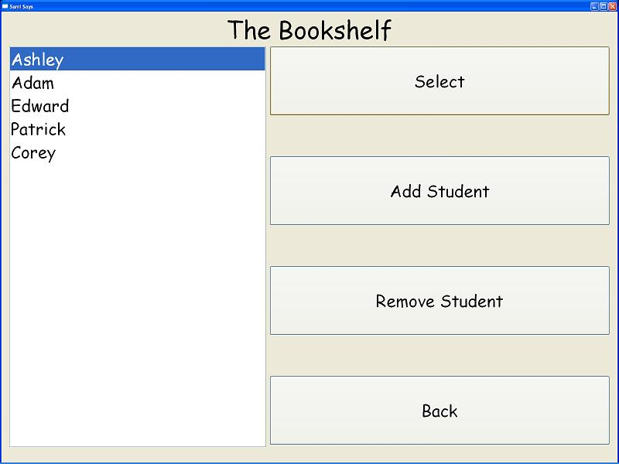
A. What is the student manager?
The student manager, or the Bookshelf, maintains a list of all the students in a class. The list, which is initially empty, will eventually be populated by student profiles. Student profiles tell Sami Says who the authors of stories are, so that they can be stored in a place that only the story’s author can access. For example, selecting student Joe from the list will produce a list of all of Joe's previous stories. If Joe creates a story, it will be saved to that list. If the teacher goes back to the student manager and selects Ann, Ann's stories and only Ann's stories will then be displayed in the list of stories. Ann will not be able to see, hear or modify Joe's stories. You can access the Bookshelf by clicking the "The Bookshelf" button from the main title page.
B. Adding a new student
New students can be added to the list of students from the student manager screen, called the Bookshelf. To add a student who is not on the list, click the "Add Student" button on the right. This will bring up a box prompting for the student’s name. Just type in the name you would like to assign to the student profile and press OK. The new student should now appear in the list on the left.
C. Removing an old student
It may occasionally be necessary to remove students from the student list. This can be done by clicking on the name of the student who you wish to delete from the list on the left and pressing the "Remove" button. You will be asked to confirm your decision, and upon confirmation the student's name will be removed from the list. The student’s stories are not irrecoverable, however, and there is a detailed explanation of how to retrieve stories from accidentally deleted student profiles in section VIX: Advanced Techniques.
D. Selecting an existing student
Once you have added students to the list on the left by following part A, you should be able to select the desired profile and begin story creation. Selecting a student means that student will be the author of the story that is to be created, and the stories will be saved under his or her name only. To select a student, click on their name in the list of students and press the "Select" button.
V: Story Management (The Storybook)
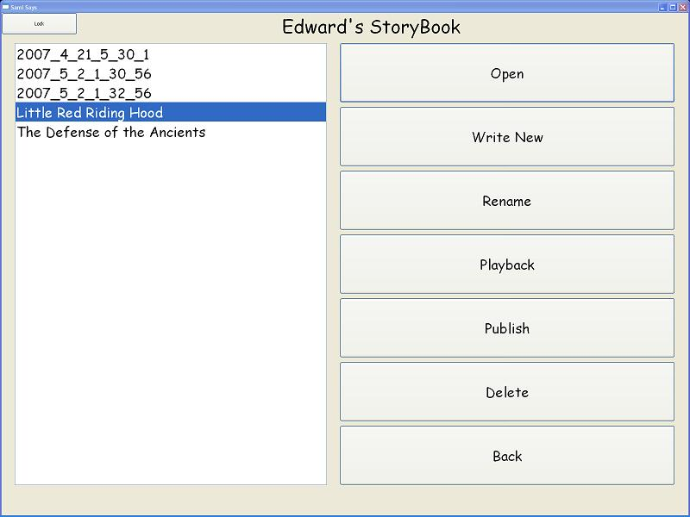
Space bar
Control
Backspace
A. What is the story manager?
The story manager, or Storybook, maintains a list of all the stories saved under a particular student. To access the story manager, you choose "The Bookshelf" from the main menu, and then select a student from the student manager (see Section IV D). From the story manager you can create new stories, hear previously created stories, rename saved stories, delete saved stories, open existing stories for editing, or publish stories. These features are described fully in the remainder of this section. *
* Navigation through this menu depends on whether you are in “locked” or “unlocked” mode, as indicated by the button in the upper left corner. If the button reads “lock” then the buttons should be clickable by the mouse. If the button reads “unlock” then only keyboard keys can be used to navigate through the menu system. You can toggle the lock by clicking the button or pressing Control Shift and Tab at the same time. All the parts of this section are assuming the interface is “unlocked” (the button reads “lock”) except for section G on keyboard navigation.
B. Creating a new story
To create a new story simply click on the "Write New" button on the right. This will take you away from the story manager and into story creation where you can hand over the computer to the student or create your own story (see section VI on how to create a story in the story creator). This story will be saved as a name that matches the date and time that the story was created. You can change this name from the story manager, explained in part D of this section.
C. Loading / Modifying an existing story
From the story manager you can load a previously created story, so that you may modify the story in story creation. To do this, select a story in the list on the left by clicking on it and then click the "Open" button on the right. This will take you away from the story manager and into story creation where the story can then be modified as if it were in the middle of being written. You should hear the title read to you to indicate that you are currently editing a story (navigate using the keybindings of story creation - see Section VI).
D. Renaming a story
Stories by default are named according to their time of creation. You can hear the different titles of the stories by clicking on each story in the list, but often you will want to name the story according to its title rather than the time it was created. To do this, click the story in the list on the left, and then click on the "Rename" button. This will bring up a box with a text box where you should type the new title for the story and click OK. You should see the story labeled the title you supplied in the list of stories to the left.
E. Publishing a story
Publishing is the name for saving the story in a format that anyone can hear, from start to finish, whether they have Sami Says installed or not. To publish a story, click the title of the story from the list on the left, and then click the "Publish" button. A dialog box will pop up that indicates the destination in which to save the story. Type the name of the file and press "Save" to save the story to that location. All published stories are saved as mp3 files. You can then email the story to the friends and family of the student so that they can hear their work. It's like giving a student his or her picture to take home and pin on the refrigerator!
F. Deleting a Story
Sometimes you may be unhappy with a previously-created story and want to delete it altogether. The best way to do this is to delete it from within the story manager or Storybook. To do this, simply click on the story in the list on the left, and click the "Delete" button. You will then be prompted to confirm the deletion. After confirming the deletion, you should see the title removed from the list of stories on the left.
G. Keyboard Navigation
So far the instructions have all explained Sami Says in terms of using the graphics on screen to navigate the menus and complete tasks; however, it is also possible to use the keyboard to navigate the Story Manager or Storybook. The purpose of this is to allow visually impaired users to change between stories without having to see the computer screen. To change between locked and unlocked buttons, either click the button in the top left corner that reads either "locked" or "unlocked" or press and hold control, shift, and tab at the same time.
Navigating through the Story Manger or Storybook with the keyboard is designed to be similar to story creation. You scroll through the stories in the story list by pressing the left and right arrows. As you scroll through the stories you should hear their titles read aloud. This indicates which story you have selected. To hear an entire story played back, press control after you have selected the desired story. You can also press the up arrow to load that story into story creation, or press backspace to delete it. To create a new story press the space bar. For help press the down arrow. Pressing escape should return you to the Students Manager or Bookshelf where you again navigate with the mouse and screen.
H. Keybindings
Create new story ______________________________________ [Space Bar]
Select previous and next story respectively _________________ [Left and Right Arrows]
Load selected story ____________________________________ [Up Arrow]
Delete selected story __________________________________ [Backspace]
Playback selected story ________________________________ [Control]
Back to Student Manager _______________________________ [Escape]
Help! (Playback keybindings) ___________________________ [Down Arrow]
Switch between mouse and keyboard input _________________ [Control + Shift + Tab]
VI Story Creation:
A. Parts of a story and the story creation screen
Stories consist only of recorded audio and sound effects. The first clip you record in a new story is always considered the title of the story. The rest of the story can contain any number of sound effects or recorded clips that you would like.
The story creation screen helps to visualize the current state of the story, as it displays all the pieces at any given time. Here is a listing of the components shown on the story creation screen:
1. Story duration – the sum of the length of all clips and sound effects
2. Current clip – the “current” clip is the selected clip on which sound modifications are made or after which sound effects or new recorded clips are inserted.
3. Recorded sounds – the number of sounds recorded by using the space bar
4. Inserted sounds – the number of sound effects inserted through the sound library
5. Manipulated sounds – the number of sound clips modified through sound manipulations
6. Locked (Teacher) sounds – the number of clips in the story that cannot be modified by the students. This number will only be greater than zero when working on an assigned teacher template.
7. Breaks – the number of beeps in the story at which the student may be asked to input a response.
8. Category – the name of the sound category currently selected (appears only when sound insertion is selected)
9. Sound – the index of the sound that is currently selected from the already selected sound category
10. Name – the name of the selected sound effect
11. Instruction box – a text box that contains the text that is spoken when the help key is pressed
12. Record light – an indicator of whether or not the student is recording (red signifies recording in process)

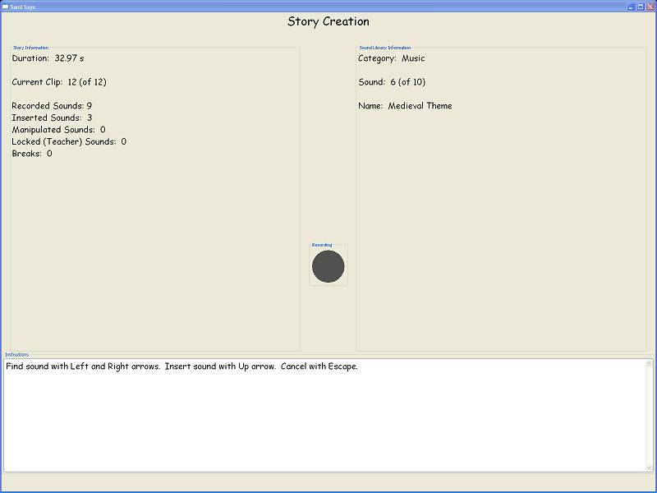
B. Creating a title
When you start creation of a new story, you must first input a title. If you are unsure what you want to name your story, that's OK. This can be changed later, but it is necessary to at least put a placeholder title in at the start. You can do this by pressing and holding the space bar while you speak the title into the microphone and releasing the space bar when finished speaking. The title will then be played back to you. If you are unhappy with it, press the backspace key twice to delete it (see section G. Deleting a clip) and then repeat the recording process again to enter a new title. You may repeat this as many times as you like. If you decide you wish to change the title at any point during creation, scroll back through the clips until you reach the title (see part E. Navigating through a story) and delete the title. You must then input a new title before returning to the point in the story where you were previously editing.
C. Recording sound clips
Once you have recorded the tile you can record the clips of your story by pressing and holding the space bar as you did with the title. Recorded clips can be anything you can capture with the microphone. You can record in incomplete sentences, full sentences, paragraphs or any other combination you'd like. Any time you record a clip you should hear it played back to you. If you are unhappy with it, simply delete it and record it again (see part G. Deleting a clip).
D. Navigating through a story
Whenever you record a clip or insert a sound effect you should hear that clip or sound effect played back. This indicates your position in the story. You can think of this like a cursor in a word processor. The clip you hear back indicates which clip will precede your next inserted sound effect or recorded clip. In other words, clips are always inserted after the clip you just heard. In this document we'll refer to this clip you just heard as the "current" clip. When you navigate through the story, the current clip will help you keep track of the point in the story at which you are editing.
So how do you navigate through the story? At any point during story creation you can move through the clips you've recorded with the arrow keys. The left arrow moves to the previous clip and the right arrow moves to the next clip. If you are at the end of the clips, the right arrow will continue to play the last clip. If you never navigate backwards during story creation, you will always be inserting clips at the end of the story, since the last clip will always be the current clip. If you navigate all the way back to the title using the left arrow, pressing the left arrow again will continue to play the title, since you can go back no farther. If you insert a clip at this point, it will be the first clip of the story after the title.
Though it may seem confusing at first, navigation is a useful tool when you find you want to change the parts of your story. It is often necessary to go back and insert sound effects when a story is too plain, or to go back and re-record a clip that doesn't sound good after hearing the whole thing. Learning how to navigate through a story is also important if you are making the story up as you go along.
E. Inserting sound effects
The sound effects in Sami Says can make a bland and boring story much more exciting and lively. There is a large library of sounds you can choose to insert at any point during story creation. First, navigate (see section D. Navigating through a story) to the clip you want the sound effect to follow and press the up arrow key. This will bring up a menu of sound effects, divided into various categories. While in this menu, the key bindings change a bit (see section J. Keybindings). Scroll through the categories with the left and right arrow keys. Every time you change categories, you should hear the computer read the name of the category aloud. When you find the category of sounds you want to select from, select the category by pressing the up arrow. Once you’ve selected the category, you can move through the sounds in the category with the left and right arrow keys. Each time you change a sound effect it should be played back to you. When you hear the sound you want to insert, press the up arrow to insert it after the current clip. You should then hear the sound effect played to you one more time, this time to indicate that it is the current clip. This simply notifies you of the point within the story at which you are editing. You can press the control key to hear the entire story with the sound effect inserted.
F. Modifying sound clips
Another cool feature of Sami Says is sound modification. You can modify any recorded clip or sound effect in Sami Says in several ways, including pitch and speed. The important distinction is that you modify a prerecorded clip or sound effect, so that the original is replaced. You do this through a special category in the sound effect insertion menu. First, navigate to any clip or sound effect that you've already inserted in your story (see section D. Navigating through a story) and press the up arrow to enter sound effect insertion. This clip will be the clip that is replaced with a modified version. Now, navigate to the "modifications" category in the sound effects menu (see section E. Inserting sound effects) and select it. Once you have selected the modifications category, scroll through the possible modifications with the left and right arrows. You should hear the current clip (the one you navigated before entering the sound effects menu) played only it should be modified. Scroll through the effects until you hear the one you want to insert. When you hear the clip played back with the modification you want, press the up arrow to replace the "current clip" with the one you just heard.
If you realize after modifying a clip that you want the original, it's not too late to get it back. See section G. Deleting a clip, to find out how to recover deleted clips (the clip you replaced is treated as if it were deleted).
G. Deleting a clip
To delete a clip that you do not want, navigate to the clip you would like to delete and press the backspace key. You will then be prompted to confirm the deletion. To confirm press the backspace key again, or press any other key to cancel. Deleted clips are not gone for good, so if you accidentally delete a clip you can recover it.
To recover a deleted clip, navigate to where you would like to restore the clip to and press the up arrow to open the sound insertion menu. Navigate to the "Trash Can" category and search through the clips until you find the deleted clip you would like to restore. Press the up arrow to insert the sound.
H. Playing the story back
To playback a story at any time, press the control key. This does not change the location in the story at which you are editing, so if you press control when the "current clip" is the fifth in a story of ten clips, whether you let the story playback or not any action you make will be made on the fifth clip.
I. Help!
If you forget the instructions you can press the enter key at any point to hear the available actions. These same instructions should also be written into the instructions box on the right for sighted viewers to read.
J. Keybindings
______________ Story Creation __________________
Record Clip ____________________________________ [Press and Hold the Space Bar]
Select previous and next clips respectively _________________ [Left and Right Arrows]
Begin Sound Insertion _______________________________ [Up Arrow]
Delete current clip or effect ___________________________ [Backspace]
Playback entire story ______________________________ [Control]
Back to Story Manager _____________________________ [Escape]
Help! (Playback keybindings) __________________________ [Enter]
______________ Sound Insertion __________________
Select previous and next categories respectively ____________ [Left and Right Arrows]
Scroll through sound effects ___________________________ [Left and Right Arrows]
Select Category/Sound _____________________________ [Up Arrow]
Jump to Start of Sound Category List ___________________ [Home]
Insert Effect ____________________________________ [Up Arrow]
Back to Story Creation (from Sound Categories) __________ [Escape]
Back to Categories (from Sound Effects) _________________ [Escape]
Help! (Playback keybindings) __________________________ [Enter]

VI Sound Library Management:

A. What is the sound library?

The sound library can be accessed within Sami Says by clicking the “Sound Prioritization” button on the title page of Sami Says. The sound library is a collection of sounds that are stored in Sami Says and accessible in story creation through sound insertion. Each sound file is associated with a category, so that sounds can be easily searched through in sound insertion. The files are really just sound files that are saved on your computer along with Sami Says, and they can be found within the Sami Says directory. If you are unfamiliar with Windows directories on your operating system, you can find out more about that in section VIX – Advanced Techniques.
The sound library can be viewed as a collection of three types of sounds: prioritized sounds, non-prioritized sounds, and sound manipulations. These sounds are all accessible through sound insertion. Prioritized sounds are just sound effects that are more accessible to students, and they can be any sound effect in the sound library. For example, if you would like your student to write a story about cats, you can prioritize only cat sounds so that your student does not have to search through the sound library every time he or she wants to insert a cat noise. Non-prioritized sounds are any sound effects that are not prioritized, not including sound manipulations. The last type of sound effect is sound manipulation. Sound manipulations are any of the possible modifications to sound clips, and they are all contained within the “Sound manipulations” category in the sound insertion menu. These are a unique type of sound effect, since they replace the current clip, and they can’t be removed from the sound library through the file structure. It is important to understand the difference between these types of sounds when modifying the sound library.
The Sound Prioritization menu in Sami Says gives the teacher the ability to restrict students to any subset of these three types of sounds. The reason this feature is included is that some teachers felt their students would be distracted by the variety and size of the sound library.

B. Prioritizing Sounds

Through the Sound Prioritization menu, teachers can select certain sounds to be moved to the front of the sound insertion categories during sound insertion. There is no limit to the sounds that can be prioritized, so you can select any number of sounds from any number of categories. This part explains how to select sounds to be prioritized.
First, navigate to the Sound Prioritization menu by clicking the “Sound Prioritization” button on the title page of Sami Says. You should now see a screen with two lists. If this is the first time you’ve been to this menu you should see a full list of the categories in the sound library on the left and an empty list on the right. This is pictured below:

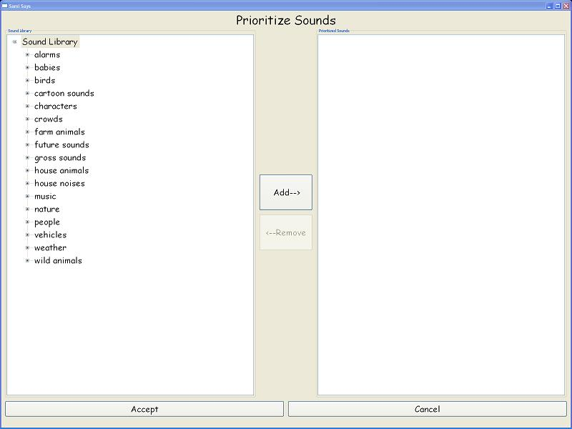

The list on the right is empty because you have not yet prioritized any sounds! Let’s do that now. From the menu on the left, select a category you want to choose from and press the [+] sign to the left to see sound effects within that category. The list should get longer, and you should see new sound effect names. Select a sound from that list and press the “Add→” button in the middle of the page. You should then see the sound effect in the list on the right. Notice that the sound still stays in the sound library to the left. This means that the sounds are simply copied to a prioritized folder, they are not removed from the normal sound library. If have a category selected when you press the “Add→” button, all sounds from that category should be copied into the list on the right. To remove a sound from the prioritized sounds, just click it in the list on the right and press the “←Remove” button. Once you have selected all the sounds you would like to prioritize, press the Accept button in the bottom left, or press Cancel to return to the title page without saving any changes.

C. Setting sound restrictions

You may have noticed three check boxes on the Sound Prioritization menu. These three boxes indicate which types of sounds students are allowed access to when creating stories. If you have all checked, which is how it should be by default, then students will have access to prioritized sounds, non-prioritized sounds, and sound manipulations. Unchecking one of these boxes will prevent students from being able to access that type of sound in story creation. For example, if you have a student who is distracted by sound manipulations, simply uncheck the box labeled “Sound Manipulations” in the “allowed sounds” portion of the Sound Prioritization menu. The student will then be unable to access the “Sound Manipulations” category from the sound insertion menu during story creation.

D. Adding new sounds

Adding new sounds requires an understanding of the Windows directory system. This is explained in more detail in section VIX – Advanced Techniques. If you understand the file system already, adding new sounds is easy. First, navigate to the Sami Says directory on your computer (default is C:\Program Files\SamiSays). Within that directory you should see a folder called “sound_library”. Open that directory and you should see many folders, each representing a sound category. This is where the sounds are stored. You can rename categories just by changing the folder name that matches the category you would like to change, and you can create a new category by making a new folder with the name of the category you wish to create; however, you will not be able to navigate to that category from within the sound insertion menu in story creation until you put a sound in the folder.
Sounds can be any of the following audio file types: .wav, .mp3, .ogg, .aiff, .and midi. Sami Says converts them to the type it uses at launch. We recommend using .mp3 or .wav files for your sound effects. To name the sound effect, just rename the sound file to what you want the name to be. Once you have a sound file ready, just drag and drop it into the folder that corresponds to the category you would like it to go under. When you next launch Sami Says you should be able to find the sound from within the Sound Prioritization menu or sound insertion during story creation.

VII Teacher Templates:

A. What is a teacher template?

To get to the teacher template menu, just click on the “Teacher Templates” button from the main interface. Teacher templates are just like any other story only their clips can’t be modified or deleted. These stories allow teachers to create assignments for their students, such as reading response or fill in the blank assignments. Teachers can also insert beeps so that their students know where to respond to questions or where to insert sound effects. The teacher template menu is pictured below.

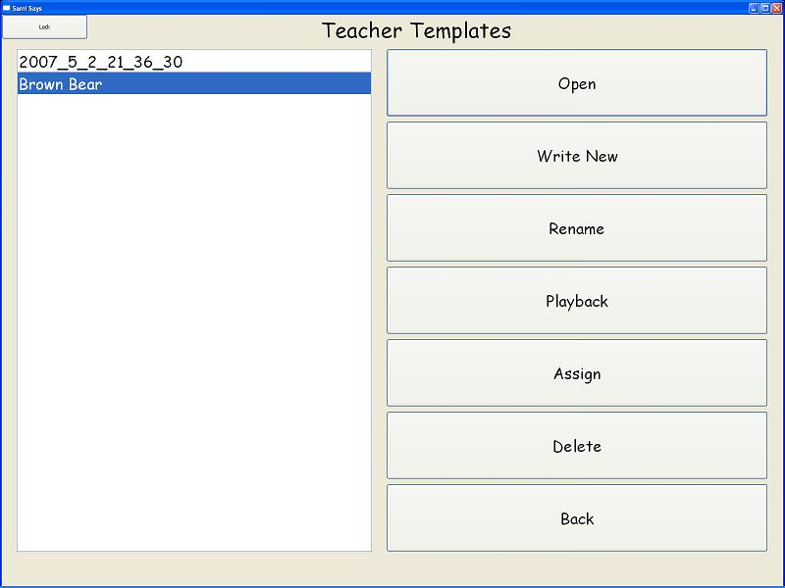

B. Creating a template

The teacher template menu is where all teacher templates that you create are stored. Notice in the sample picture above there are two templates in the menu. When you first launch the teacher templates menu this list should be empty, and you will need to create a new one. To do this, simply click the “Write New” button on the right. You should then be taken to the story creation screen.
There is only one difference between template creation and story creation and that is the insertion of breaks or beeps. These beeps have two purposes: the first is to indicate to the student where he or she should insert a response and the second is to divide the clips into coherent blocks. For example, if you wanted to create a reading comprehension test for students you could record each sentence in the first paragraph of The Little Red Hen, shown below:

A Little Red Hen lived in a barnyard. She spent almost all of her time
walking about the barnyard in her picketty-pecketty fashion,
scratching everywhere for worms.

This would result in just two clips, the first being the first sentence and the second consisting of the second sentence (not including a title). Now you want the student to respond to the first paragraph, so you ask “Where does the Little Red Hen live?” You would then insert a beep to indicate to the student he or she should respond to your question. Also, when this story is assigned to a student they will only receive one clip in addition to the title. The only clip in the assigned story will be the entire paragraph above plus the question, followed by the beep. In this way, beeps allow you to both divide the story into conceptually coherent blocks, as well as give a cue to the student where he or she should insert their own recordings. You could also insert a beep before and after your question, so that the question is separate from the passage altogether.
All you have to do to insert a beep is press the “Pause/Break” key, usually found on the upper right portion of the keyboard near the insert key, and the beep will be placed into the story. You should hear a beep to indicate that the sound has been inserted. The beeps function like any sound effect during template creation, and can be modified or deleted as you like. It is only when you assign the template to a student that the story becomes packaged into blocks of clips separated by the beeps. Also, when you assign the template to a student you will have the ability to make the beeps silent, so if you only want to use beeps to break the story into pieces you would want to select this option during template assignment.

C. Assigning a template

Once you have created a template you will likely want to assign it to a student. To do this, return to the Teacher Templates menu and select the template you want to assign from the menu in the left. If you have not renamed the story, it will appear in the list as the date and time of its creation. Before you assign it you should rename it, otherwise it will be stored in the students’ storybooks with a date for a title. Once you’ve renamed the story, make sure it is selected and press the “Assign” button. A window like the one below should pop up, with check boxes for every student in your class.

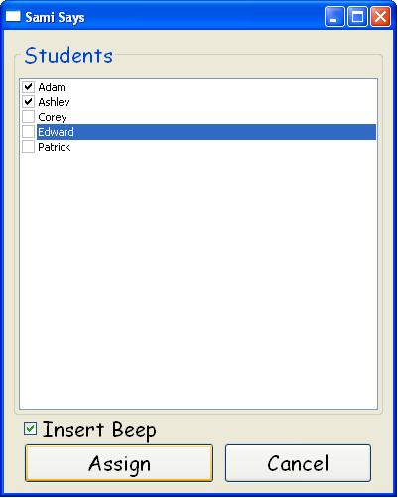

Check the students you wish to assign the template to and then uncheck the “Insert Beep” box at the bottom if you wish the beeps to be silent. This will keep the story in the blocks that you separated with the beeps, but there will be no beeps played in between the clips. Once you are done, press the “Assign” button to assign it to the checked students. You should see a confirmation dialog if the template was assigned correctly. Now the template should appear in each of the checked students’ Storybooks as if it were one of their stories.

D. Deleting a template

You may wish to delete an old template or one that you just don’t like anymore. To do this just get to the Teacher Template menu and select the template you would like to delete from the list on the left. Once it is selected, press the “Delete” button on the right. You should see a confirmation window pop up, and once you confirm the template will be removed from the list on the left. It is impossible to recover these deleted templates, so make sure you don’t want them any more before deleting them.

E. Keybindings

Template creation has keybindings similar to story creation, with the addition of the Pause/Break button to insert beeps. It is important to note that though you can navigate through the Teacher Template menu using the keyboard, you cannot assign it to a student unless the interface is unlocked. To lock or unlock the buttons, click the button in the top left corner.

______________ Template Creation __________________
Record Clip ____________________________________ [Press and Hold the Space Bar]
Select previous and next clips respectively _______________ [Left and Right Arrows]
Begin Sound Insertion _______________________________ [Up Arrow]
Delete current clip or effect ___________________________ [Backspace]
Playback entire story ______________________________ [Control]
Back to Story Manager _____________________________ [Escape]
Help! (Playback keybindings) __________________________ [Enter]
Add Beep __________________________________________ [Pause/Break]

VIX Advanced Techniques:
A. Sound library structure

If you know how to find the Sami Says directory on your operating system, you can easily modify the sounds directly. This section explains how to manipulate the sound library using the operating system file structure. The easiest way to get to the sound library is to go to the Start menu from the desktop. This is located in the bottom left hand corner by default. From the Start menu go to Programs and then find Sami Says in the list of programs. Under Sami Says you should see three items: Sami Says, Uninstall Sami Says, and Sami Says Sound Library. Right click the Sami Says Sound Library item and click “Open” to view the sound categories in the library, shown here:
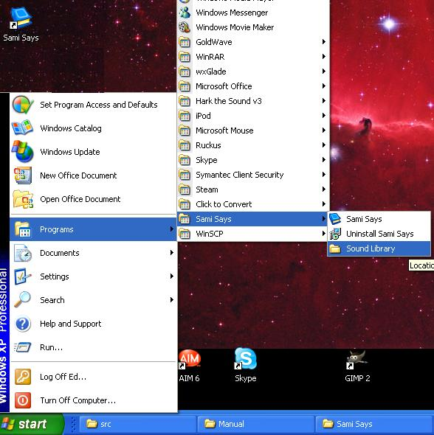

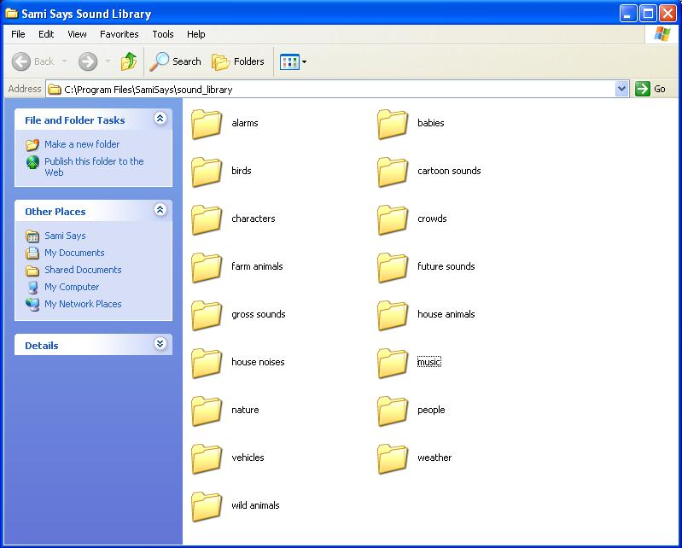
You will notice that there is a folder for each sound category. Each sound is stored in a folder that corresponds to its category title. For example, all the sound effects that are found under the “Music” category in sound insertion are stored in a folder within Sami Says called “music”. This is how the game knows the category for any sound effect. If you were to change the folder name to “Cool beats”, you would no longer see a “Music” category in sound insertion, but you would see a new category called “Cool beats.” If the category folder has any sound files in it, Sami Says will find them and allow the students to insert them in stories. Therefore, to create a new category all you have to do is create a new folder in the Sami Says Sound Library folder. To do this, right click in the window shown above and click “New -> Folder”. Name the folder whatever you want the category name to be by typing the name now. You now have a new category! This category will not appear in the sound insertion menu until you put sound files in it. To learn how to add new sounds to the category you created, see section VI Sound Library Management: D Adding new sounds.

C. Copy/Cut/Paste a sound clip

If you want to duplicate a clip or sound effect, one easy way to do this is by using the delete function. Any clip that is deleted is stored in the “Trash Can” sound category in sound insertion. This trash can is emptied when you exit your story, so make sure to confirm that no sounds you want to keep will be lost when you exit. The trash can allows for duplication of clips because any time you insert clips from the trash can, they are not removed from the trash can. So any clip you delete can be reinserted multiple times. So if you wish to duplicate a clip, you should first delete the clip you want to duplicate. Then, search through the trash can for the clip you want to duplicate and insert it. Repeat any number of times until you have the desired number of clips. You can also use this technique to move clips through the story. For example, if you have a clip at the end of the story but want to put it at the beginning, first delete the clip then navigate to the front of the story. Then, search the trash can for the clip and insert it in the desired location.

X. About the team:

Sami Says was developed by four computer science undergraduate students at the University of North Carolina at Chapel Hill under Professor Gary Bishop, who specializes in assistive technologies. The game was commissioned by Diane Brauner, a local school teacher for visually impaired children, and she provided much of the input during the game’s development. Corey Davis was primarily responsible for the sound manipulations and installation software. Patrick Reynolds programmed most of the graphical user interfaces, and Adam Roberts handled programming of game functionality. Edward Rowe constructed the sound library and documentation for Sami Says. Corey and Edward will begin work with local video game companies after graduation, and Patrick will start work with a medical graphics software company in Carrboro. Adam Roberts is going to work for Tech for America for a year before attending graduate school for Computational Biology at the University of Washington or Berkeley.

